Cypress AYSO 154
Fundraiser Night
Saturday October 17, 2026 7pm
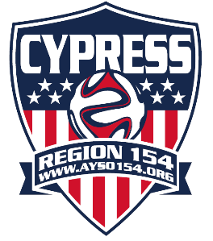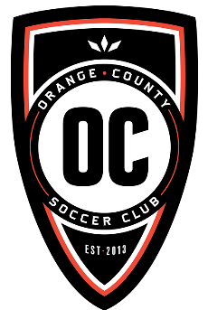
Experience professional soccer in Orange County and visit the interactive Fan Zone with lawn games, balloon artist, face painting, food vendors and Craft beers. Special experience for Cypress 154 players. The team that sells the most tickets will be able to scrimmage at halftime during the game!
Championship Stadium Irvine
Tickets are $10 each (50% off regular ticket prices)
A portion of each ticket sale goes directly to support Region 154.
Payments by cash or check.
Purchase tickets as a team before 10/10 . Coordinate payment with Board Member. Tickets distributed at LJHS 10/11
Tickets are limited to the first 100 tickets sold!
*upgrade your ticket to the Beerfest event for $35 more direct through OC Soccer(with coupon code) 5pm entrance/unlimited beer

Bring the Team! Bring the Family! Bring the Fun!

Visit www.ayso154cypress.org for more information and follow us on social media
Email:youthrefprogram154@gmail.com or Division Directors

Name:
Number of tickets:
Coach’s name:
Email: If upgrading to Beerfest ticket.
$35 additional direct with OC Soccer

Ticket Purchase Process – AYSO 154 Fundraiser
General Overview
This process outlines how team parents can purchase tickets for the upcoming AYSO 154 fundraiser event. Please follow the steps below to ensure a smooth and organized ticket process.

Step-by-Step Instructions
- Team Payment Collection
  - Team parents are responsible for collecting cash or checks from their team members to make a group payment.
- Ticket Request & Pickup Coordination
  - To arrange ticket pickup, contact Troy Baron or a Board Volunteer at:
📧 youthrefprogram154@gmail.com
    - Be sure to copy your Division Director on the email.
  - Pickup may be scheduled at a practice site location, subject to availability.
- Ticket Availability
  - Tickets are limited to the first 100 sold.
⏳ Act quickly to secure your team’s tickets!
- Payment Method
  - Pay in person using a QR code provided at the pickup location.
  - Provide your team information during the transaction.
- Receipt Exchange
  - Upon payment, you will receive a digital receipt number in exchange for your cash or check.
- Ticket Distribution
  - Tickets will be available for pickup at:
📍 Lexington Junior High School
📅 Saturday, October 10
⏰ Time: TBD

Additional Information
- Beerfest Tickets
These are sold separately through OC Soccer via a dedicated link.
  - Fundraiser Requirement
All attendees must purchase an AYSO 154 $10 Fundraiser Ticket to participate.

